**Project Planning Phase**

**Project Planning Template (Product Backlog, Sprint Planning, Stories, Story points)**

| Date | 18 October 2022 |
| --- | --- |
| Team ID | PNT2022TMID19343 |
| Project Name | IoT Based Safety Gadget for Child Safety Monitoring & Notification |
| Maximum Marks | 8 Marks |

**Product Backlog, Sprint Schedule, and Estimation (4 Marks)**

Use the below template to create product backlog and sprint schedule

| **Sprint** | **Functional Requirement (Epic)** | **User Story Number** | **User Story / Task** | **Story Points** | **Priority** | **Team Members** |
| --- | --- | --- | --- | --- | --- | --- |
| Sprint-1 | Registration | USN-1 | As a user, I can register for the application through Gmail | 5 | High | Mahalakshmi.M.K |
| Sprint-2 | Dashboard | USN-2 | As a user, I can get alert notification, when the child moves out of the geofence | 20 | Medium | Logapriya.K |
| Sprint-1 | Confirmation | USN-3 | As a user, I will receive confirmation email once I have registered for the application | 5 | High | Purnimah.S.V |
| Sprint-1 | Notification | USN-4 | As a user, I can track the child’s location | 10 | High | Prawin.R |
| Sprint-3 | Support | USN-5 | As a user, I will get a call incase of emergency | 20 | High | Prawin.R |
| Sprint-4 | Logout | USN-6 | As a user, I can logout of this application | 20 | Low | Logapriya.K |

**Project Tracker, Velocity & Burndown Chart: (4 Marks)**

| **Sprint** | **Total Story Points** | **Duration** | **Sprint Start Date** | **Sprint End Date (Planned)** | **Story Points Completed (as on Planned End Date)** | **Sprint Release Date (Actual)** |
| --- | --- | --- | --- | --- | --- | --- |
| Sprint-1 | 20 | 6 Days | 24 Oct 2022 | 29 Oct 2022 | 20 | 29 Oct 2022 |
| Sprint-2 | 20 | 6 Days | 31 Oct 2022 | 05 Nov 2022 | 20 | 05 Nov 2022 |
| Sprint-3 | 20 | 6 Days | 07 Nov 2022 | 12 Nov 2022 | 20 | 12 Nov 2022 |
| Sprint-4 | 20 | 6 Days | 14 Nov 2022 | 19 Nov 2022 | 20 | 19 Nov 2022 |

**Velocity:**

Imagine we have a 10-day sprint duration, and the velocity of the team is 20 (points per sprint). Let’s calculate the team’s average velocity (AV) per iteration unit (story points per day)

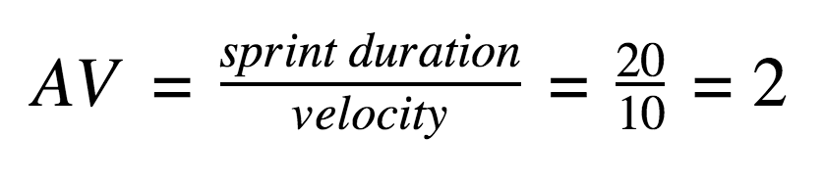

**Burndown Chart:**

